# **Q1 — FA for 3 consecutive 1’s (111)**

#include <iostream>

#include <string>

using namespace std;

void State0(string w, int i);

void State1(string w, int i);

void State2(string w, int i);

void State3(string w, int i);

int main() {

string w;

cout << "Enter a string: ";

cin >> w;

State0(w, 0);

return 0;

}

void State0(string w, int i) {

if (i == w.length()) {

cout << "String is rejected\n";

return;

}

if (w[i] == '1')

State1(w, i + 1);

else

State0(w, i + 1);

}

void State1(string w, int i) {

if (i == w.length()) {

cout << "String is rejected\n";

return;

}

if (w[i] == '1')

State2(w, i + 1);

else

State0(w, i + 1);

}

void State2(string w, int i) {

if (i == w.length()) {

cout << "String is rejected\n";

return;

}

if (w[i] == '1')

State3(w, i + 1);

else

State0(w, i + 1);

}

void State3(string w, int i) {

cout << "String is accepted\n";

}

Output:

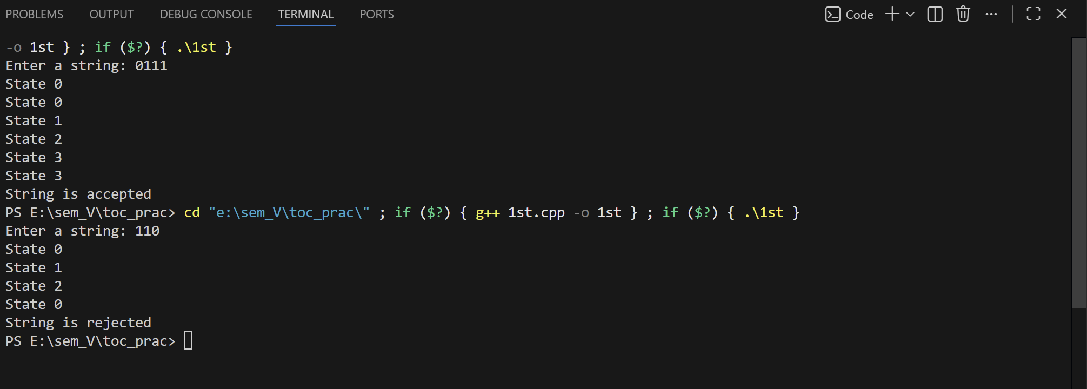

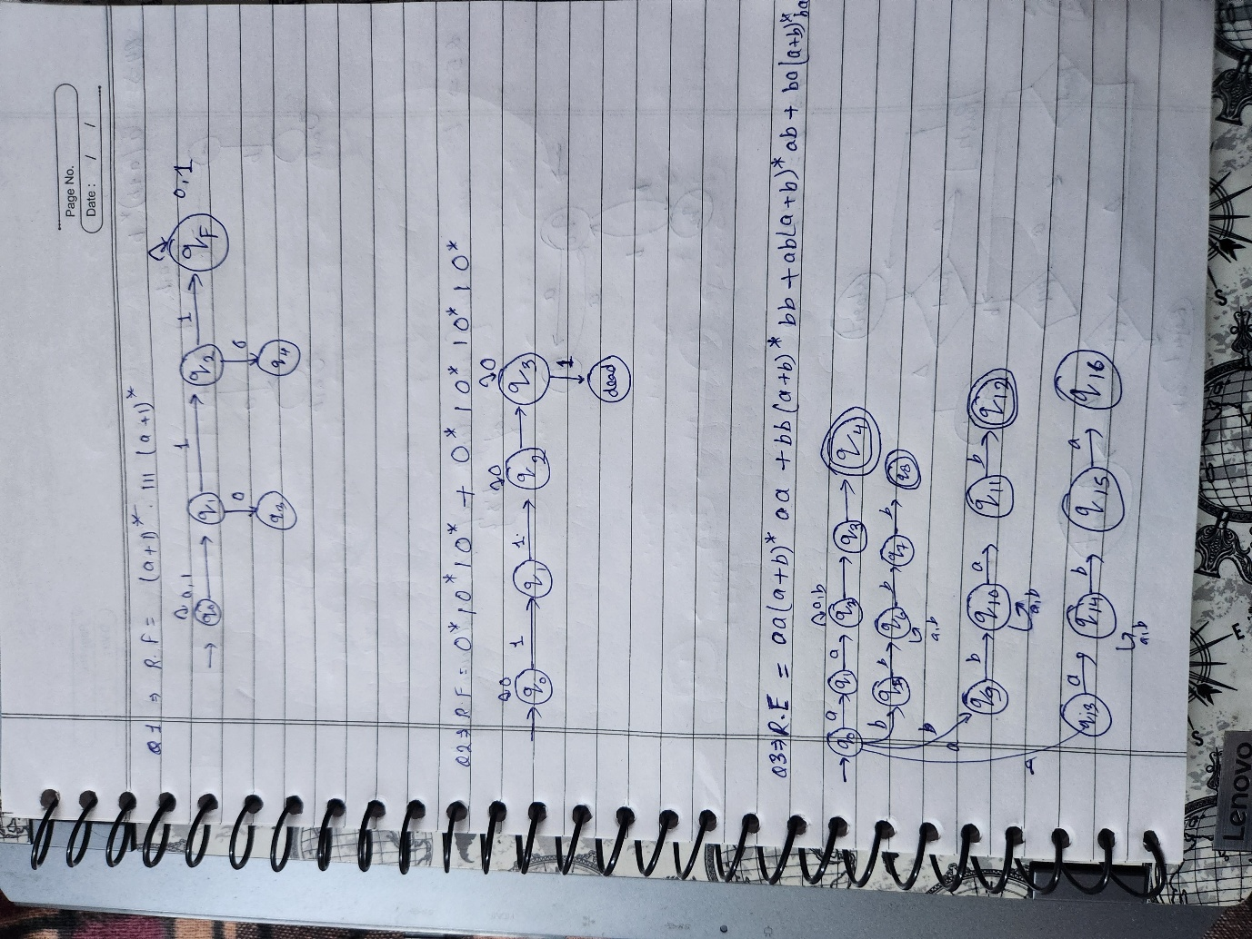

# **Q2 — FA for exactly two or exactly three 1’s**

#include <iostream>

#include <string>

using namespace std;

void State0(string w, int i);

void State1(string w, int i);

void State2(string w, int i);

void State3(string w, int i);

void State4(string w, int i);

int main() {

string w;

cout << "Enter a binary string: ";

cin >> w;

State0(w, 0);

return 0;

}

void State0(string w, int i) {

if (i == w.length()) {

cout << "String is rejected\n";

return;

}

if (w[i] == '1') State1(w, i + 1);

else State0(w, i + 1);

}

void State1(string w, int i) {

if (i == w.length()) {

cout << "String is rejected\n";

return;

}

if (w[i] == '1') State2(w, i + 1);

else State1(w, i + 1);

}

void State2(string w, int i) {

if (i == w.length()) {

cout << "String is accepted\n";

return;

}

if (w[i] == '1') State3(w, i + 1);

else State2(w, i + 1);

}

void State3(string w, int i) {

if (i == w.length()) {

cout << "String is accepted\n";

return;

}

if (w[i] == '1') State4(w, i + 1);

else State3(w, i + 1);

}

void State4(string w, int i) {

if (i == w.length()) {

cout << "String is rejected\n";

return;

}

State4(w, i + 1);

}

Output:

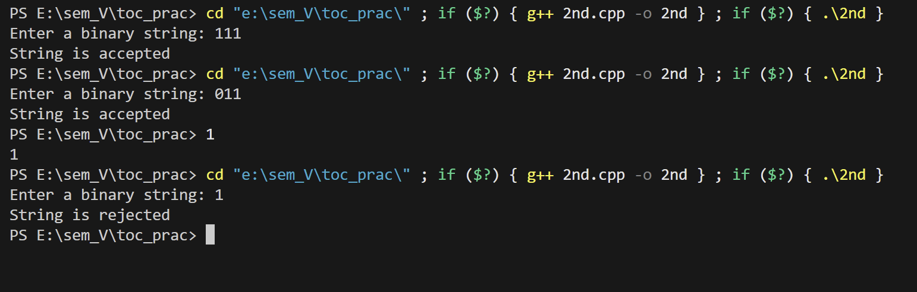

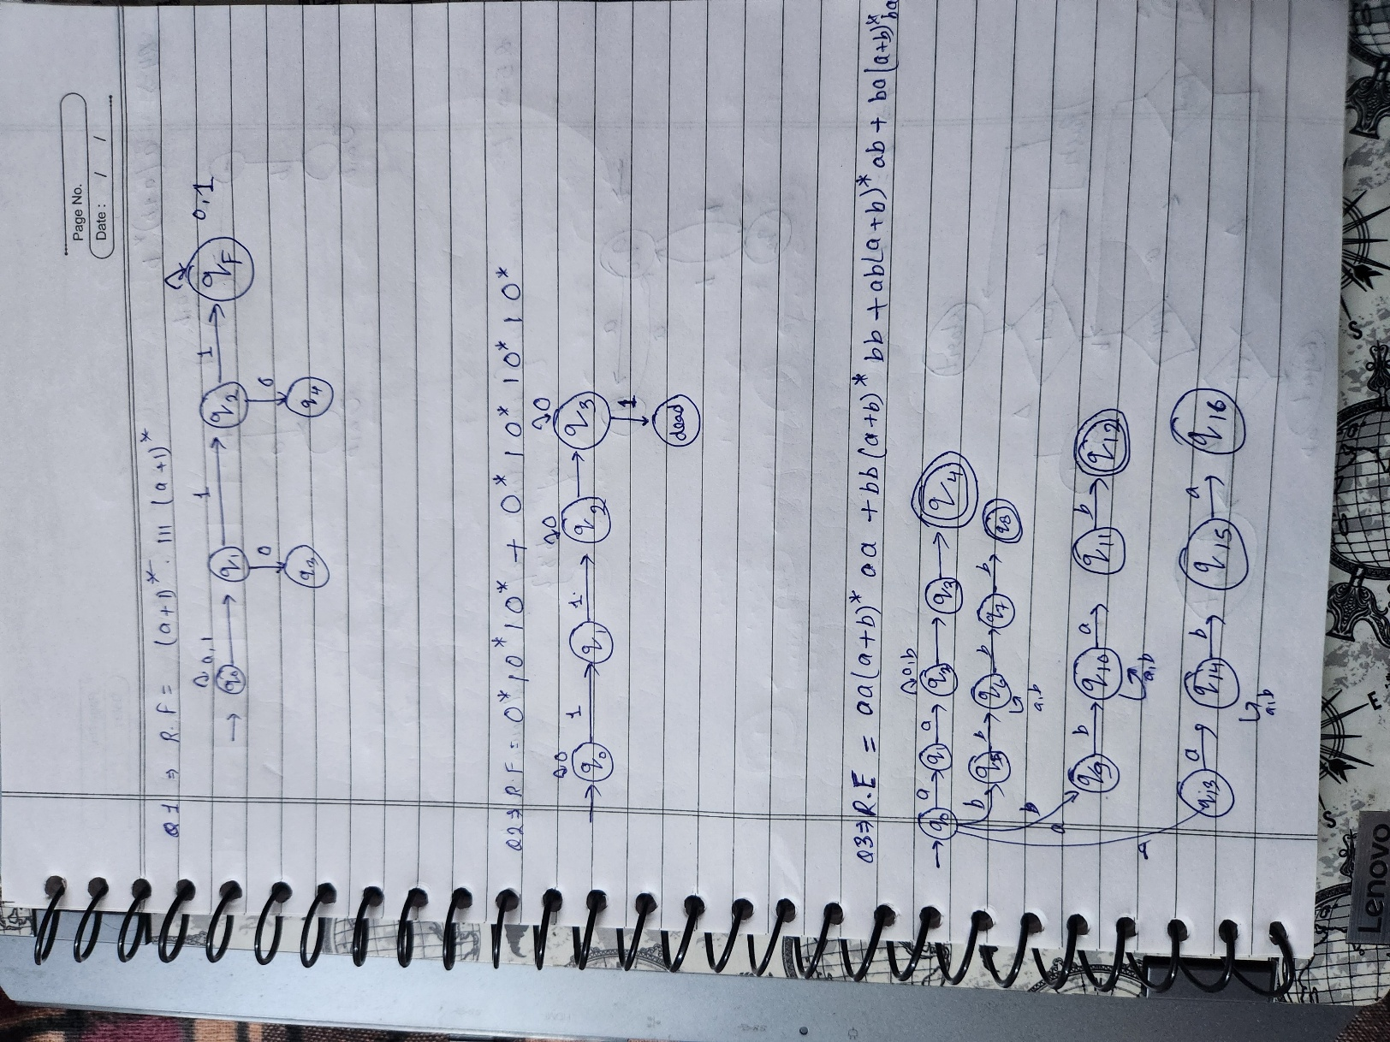

# **Q3 — First two characters = last two (|w| ≥ 4)**

#include <iostream>

#include <string>

using namespace std;

void State0(string w, int i, char first, char second);

void State1(string w, int i, char first, char second);

void State2(string w, int i, char first, char second);

void State3(string w, int i, char first, char second);

int main() {

string w;

cout << "Enter a string over {a, b}: ";

cin >> w;

if (w.length() < 4) {

cout << "String is rejected\n";

return 0;

}

State0(w, 0, '\0', '\0');

return 0;

}

void State0(string w, int i, char first, char second) {

if (i >= 2) {

State1(w, i, first, second);

} else {

if (i == 0) first = w[i];

if (i == 1) second = w[i];

State0(w, i + 1, first, second);

}

}

void State1(string w, int i, char first, char second) {

if (i == w.length() - 2) {

State2(w, i, first, second);

} else {

State1(w, i + 1, first, second);

}

}

void State2(string w, int i, char first, char second) {

if (w[i] == first && w[i + 1] == second) {

State3(w, i, first, second);

} else {

cout << "String is rejected\n";

}

}

void State3(string w, int i, char first, char second) {

cout << "String is accepted\n";

}

Output:

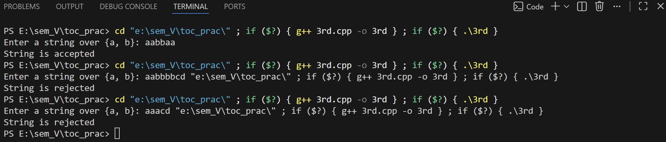

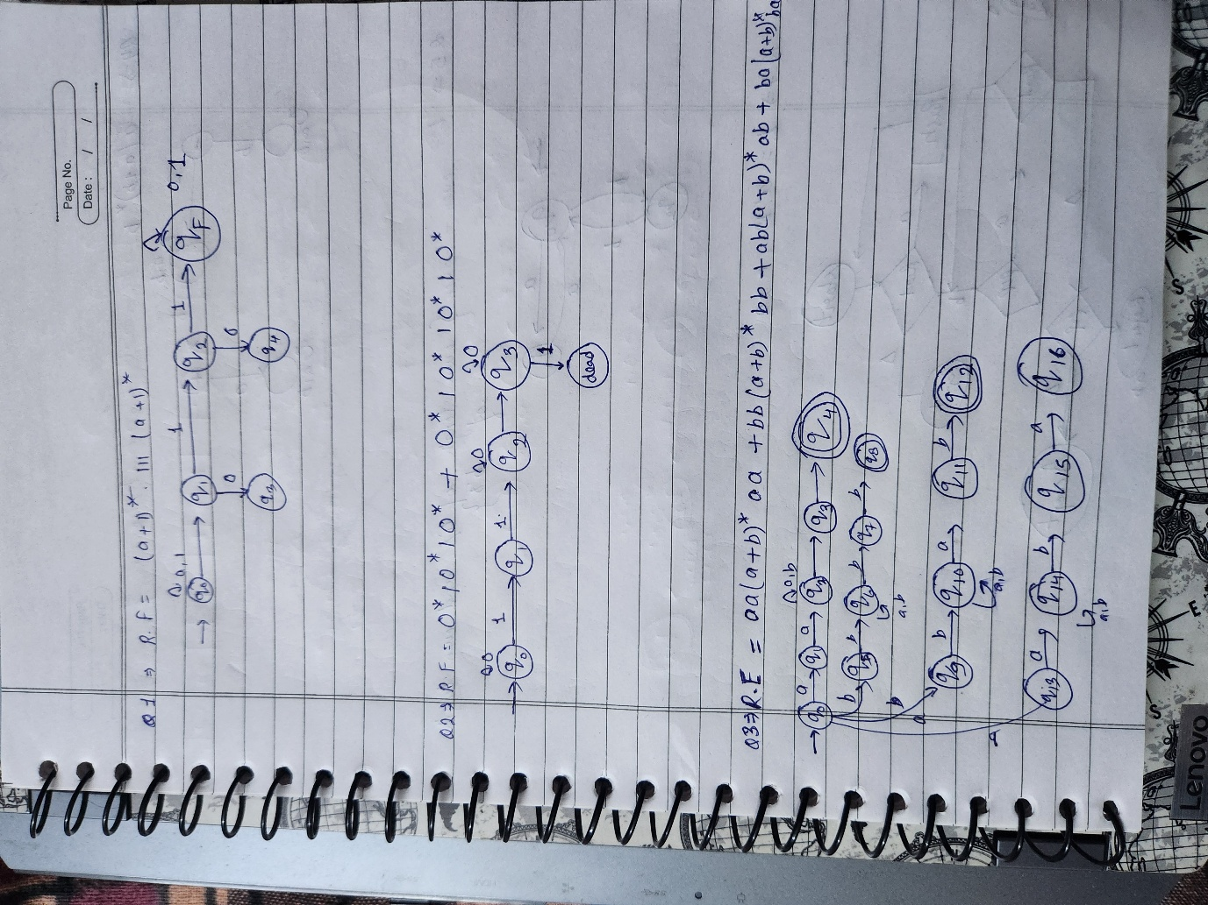

# **Q4 — L2 = a(a+b)*b**

#include <iostream>

#include <string>

using namespace std;

void State1(string w, int i);

void State2(string w, int i);

void State3(string w, int i);

int main() {

string w;

cout << "Enter string: ";

cin >> w;

State1(w, 0);

return 0;

}

void State1(string w, int i) {

if (i == w.length()) {

cout << "String is accepted\n";

return;

}

if (w[i] == 'a') State2(w, i + 1);

else if (w[i] == 'b') State1(w, i + 1);

}

void State2(string w, int i) {

if (i == w.length()) {

cout << "String is accepted\n";

return;

}

if (w[i] == 'b') State1(w, i + 1);

else if (w[i] == 'a') State3(w, i + 1);

}

void State3(string w, int i) {

if (i == w.length()) {

cout << "String is rejected\n";

return;

}

if (w[i] == 'a' || w[i] == 'b') State3(w, i + 1);

}

Output:

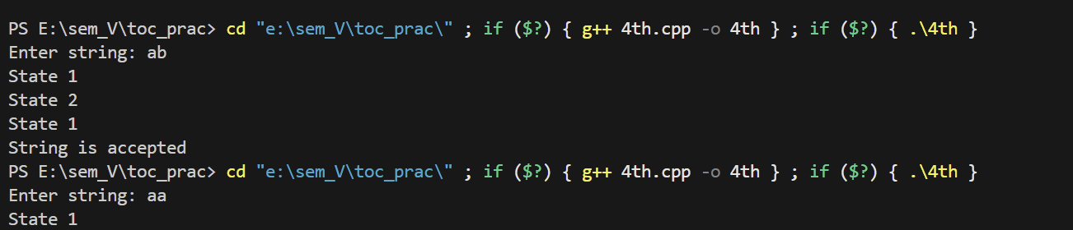

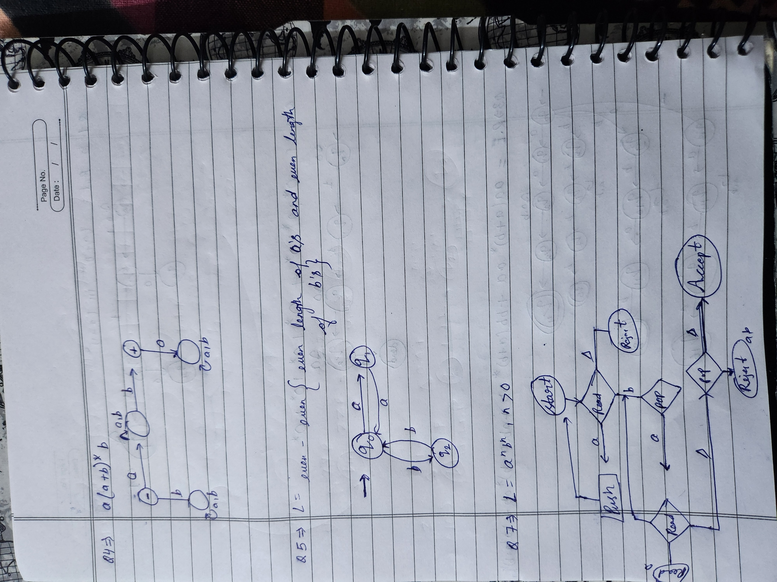

# **Q5 — EVEN-EVEN language (even a’s, even b’s)**

(Fixed, correct version)

#include <iostream>

#include <string>

using namespace std;

void State1(string w, int i);

void State2(string w, int i);

void State3(string w, int i);

void State4(string w, int i);

int main() {

string w;

cout << "Enter string: ";

cin >> w;

State1(w, 0);

return 0;

}

void State1(string w, int i) { // even a, even b

if (i == w.length()) { cout<<"Accepted\n"; return; }

if (w[i]=='a') State2(w,i+1);

else State3(w,i+1);

}

void State2(string w, int i) { // odd a, even b

if (i == w.length()) { cout<<"Rejected\n"; return; }

if (w[i]=='a') State1(w,i+1);

else State4(w,i+1);

}

void State3(string w, int i) { // even a, odd b

if (i == w.length()) { cout<<"Rejected\n"; return; }

if (w[i]=='a') State4(w,i+1);

else State1(w,i+1);

}

void State4(string w, int i) { // odd a, odd b

if (i == w.length()) { cout<<"Rejected\n"; return; }

if (w[i]=='a') State3(w,i+1);

else State2(w,i+1);

}

Output:

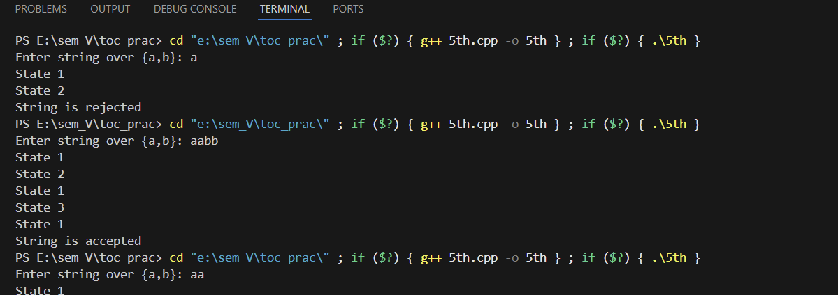

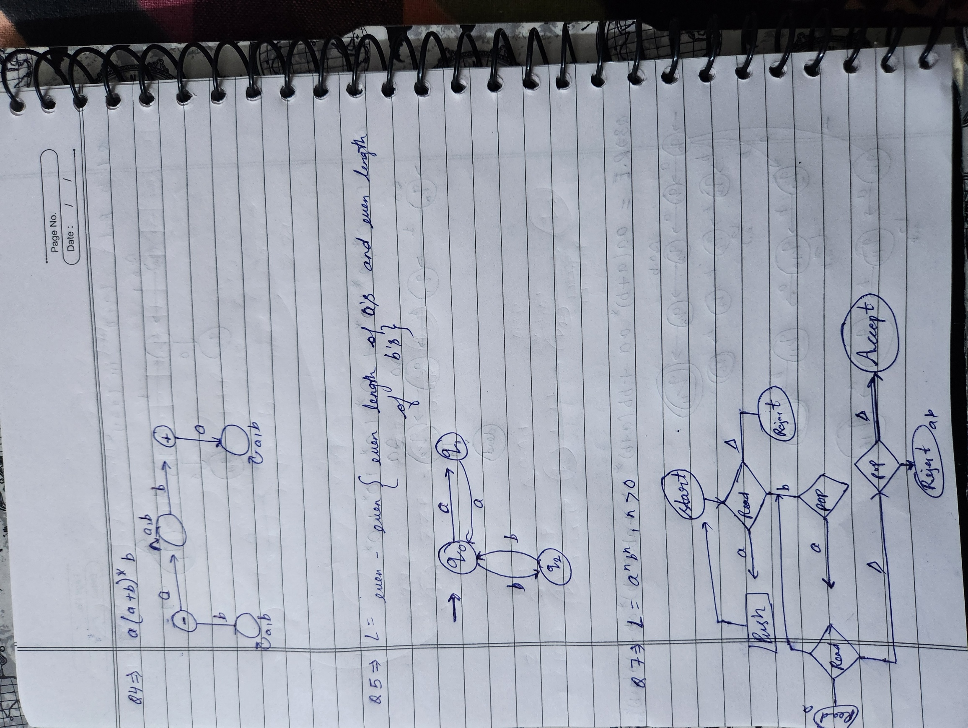

# 

# **Q6 — Union, Intersection, Concatenation**

#include <iostream>

#include <cstring>

using namespace std;

int unionLanguage(char* w) {

int len = strlen(w);

if (w[0]=='a') return 1;

if (w[len-1]=='b') return 1;

return 0;

}

int intersectionLanguage(char* w) {

int len = strlen(w);

if (w[0]=='a' && w[len-1]=='b') return 1;

return 0;

}

int concatenationLanguage(char* w) {

int len = strlen(w);

if (w[0]=='a' && w[len-1]=='b') return 1;

return 0;

}

int main() {

char w[100];

cout<<"Enter string: ";

cin>>w;

cout<<"Union: "<<(unionLanguage(w)?"Accepted":"Rejected")<<"\n";

cout<<"Intersection: "<<(intersectionLanguage(w)?"Accepted":"Rejected")<<"\n";

cout<<"Concatenation: "<<(concatenationLanguage(w)?"Accepted":"Rejected")<<"\n";

return 0;

}

Output:

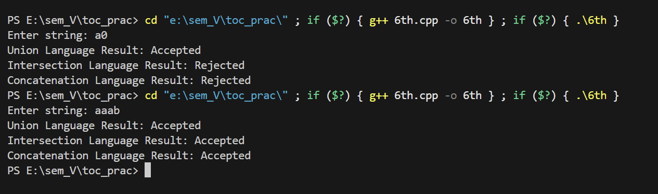

# **Q7 — PDA for aⁿbⁿ**

#include <iostream>

#include <stack>

#include <cstring>

using namespace std;

int simulatePDA(char* input) {

stack<char> s;

int len = strlen(input);

for(int i=0;i<len;i++){

if(input[i]=='a') s.push('a');

else if(input[i]=='b'){

if(s.empty()) return 0;

s.pop();

}

else return 0;

}

return s.empty();

}

int main() {

char input[100];

cout<<"Enter string: ";

cin>>input;

cout<<(simulatePDA(input)?"Accepted":"Rejected")<<"\n";

return 0;

}

Output:

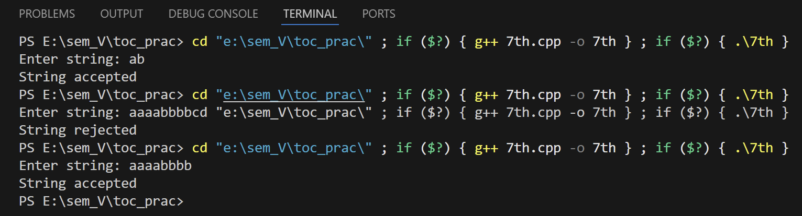

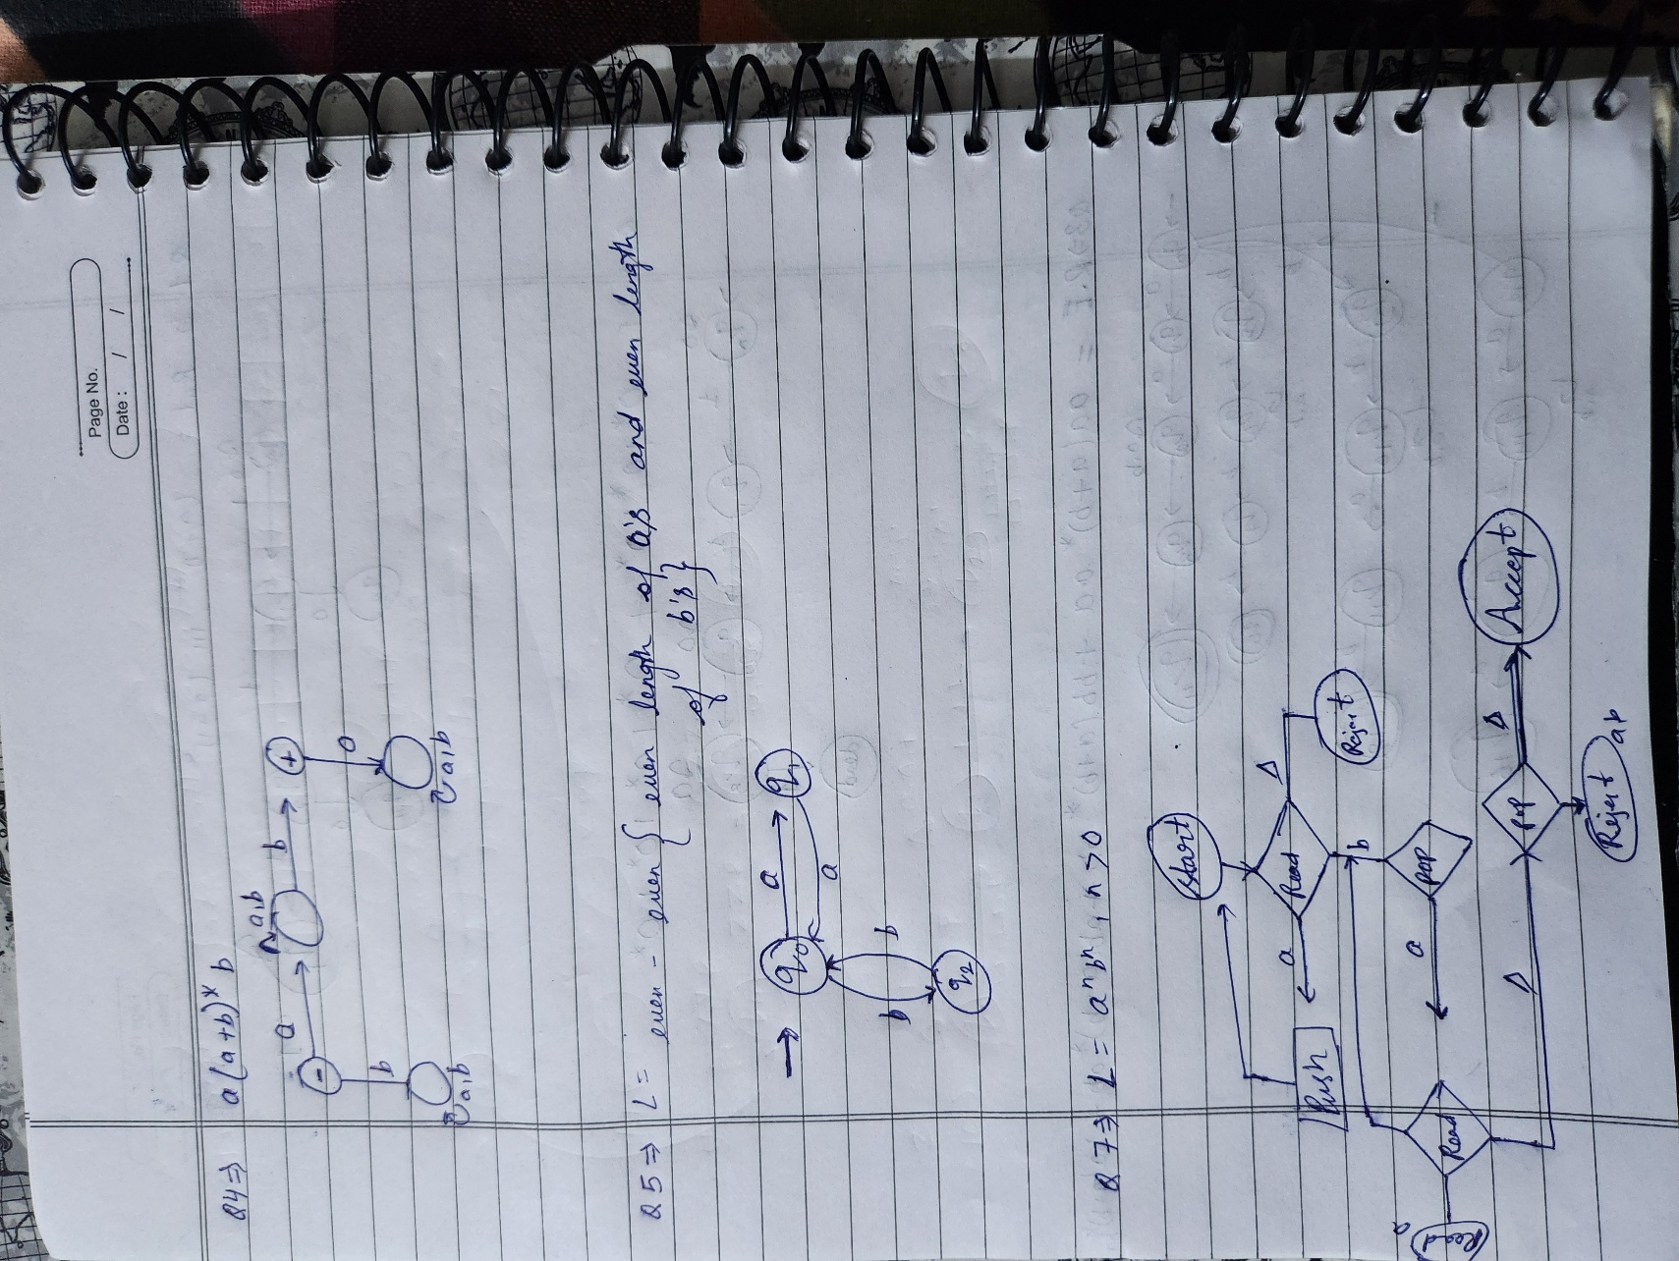

# 

# **Q8 — PDA for w X wʳ**

#include <iostream>

#include <stack>

#include <string>

using namespace std;

bool simulate(string w) {

stack<char> s;

bool seenX = false;

for(char c : w){

if(!seenX){

if(c=='a' || c=='b') s.push(c);

else if(c=='X') seenX=true;

else return false;

}

else{

if(s.empty() || s.top()!=c) return false;

s.pop();

}

}

return seenX && s.empty();

}

int main() {

string w;

cout<<"Enter string: ";

cin>>w;

cout<<(simulate(w)?"Accepted":"Rejected")<<"\n";

return 0;

}

Output:

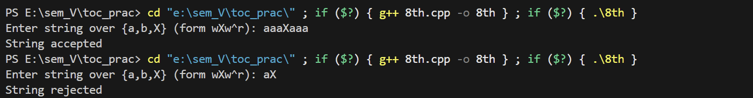

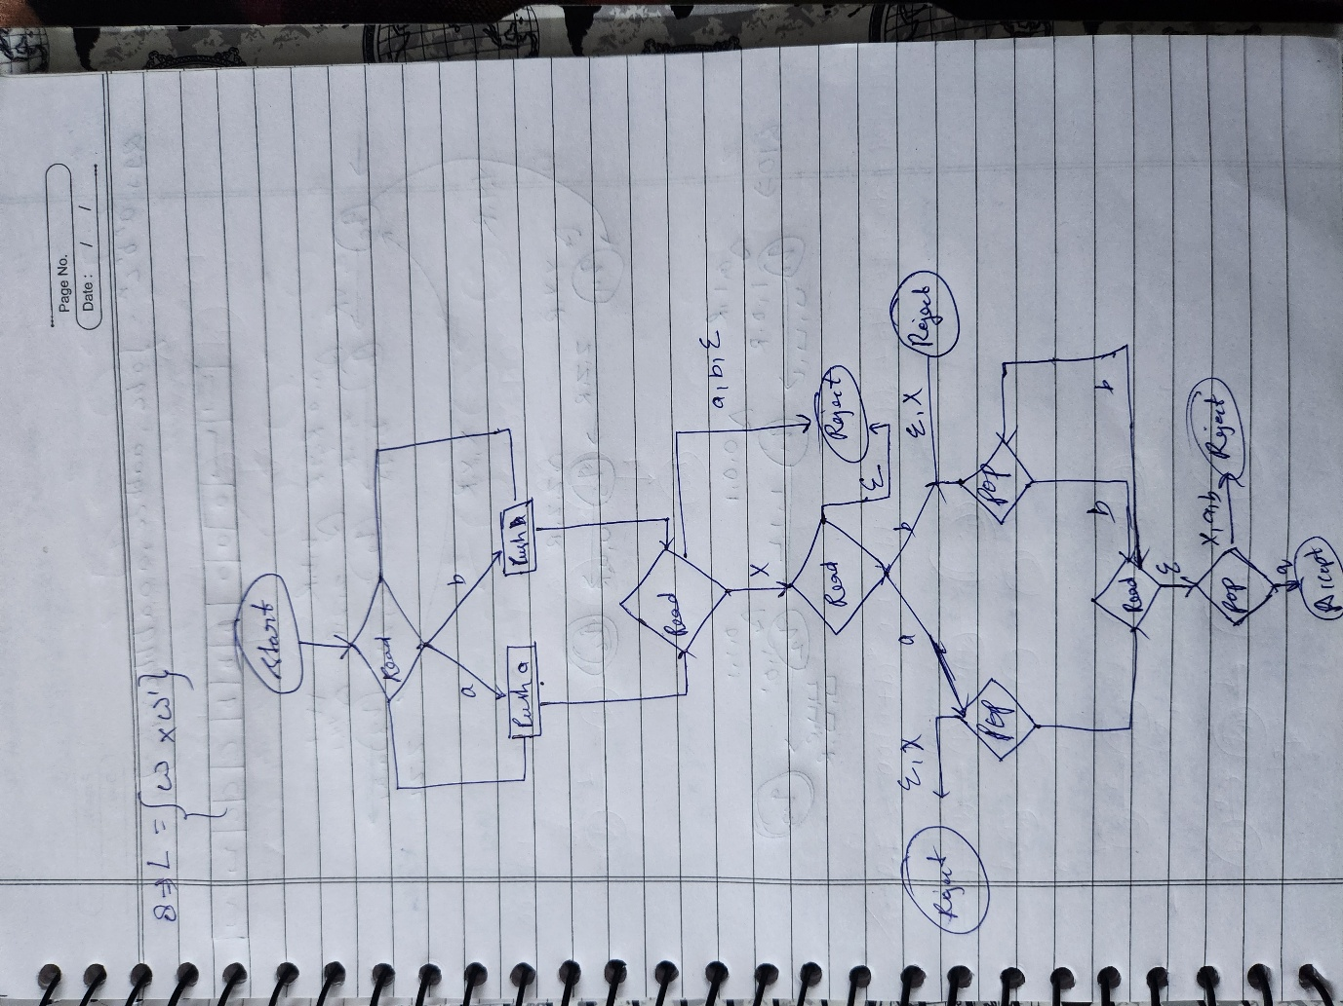

# 

# **Q9 — TM for aⁿbⁿcⁿ (corrected)**

#include <iostream>

#include <cstring>

using namespace std;

int simulate(char* input) {

int len=strlen(input);

int i=0,a=0,b=0,c=0;

while(i<len && input[i]=='a'){a++; i++;}

while(i<len && input[i]=='b'){b++; i++;}

while(i<len && input[i]=='c'){c++; i++;}

if(i!=len) return 0;

if(a==0 || b==0 || c==0) return 0;

return (a==b && b==c);

}

int main() {

char w[100];

cout<<"Enter string: ";

cin>>w;

cout<<(simulate(w)?"Accepted":"Rejected")<<"\n";

return 0;

}

Output:

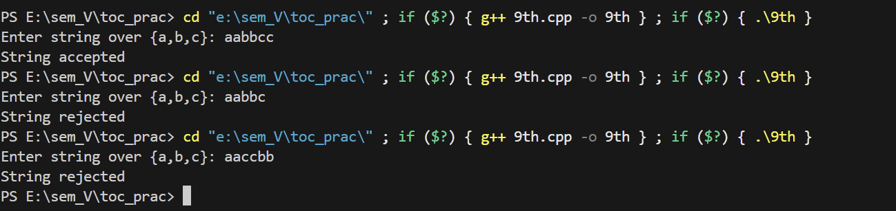

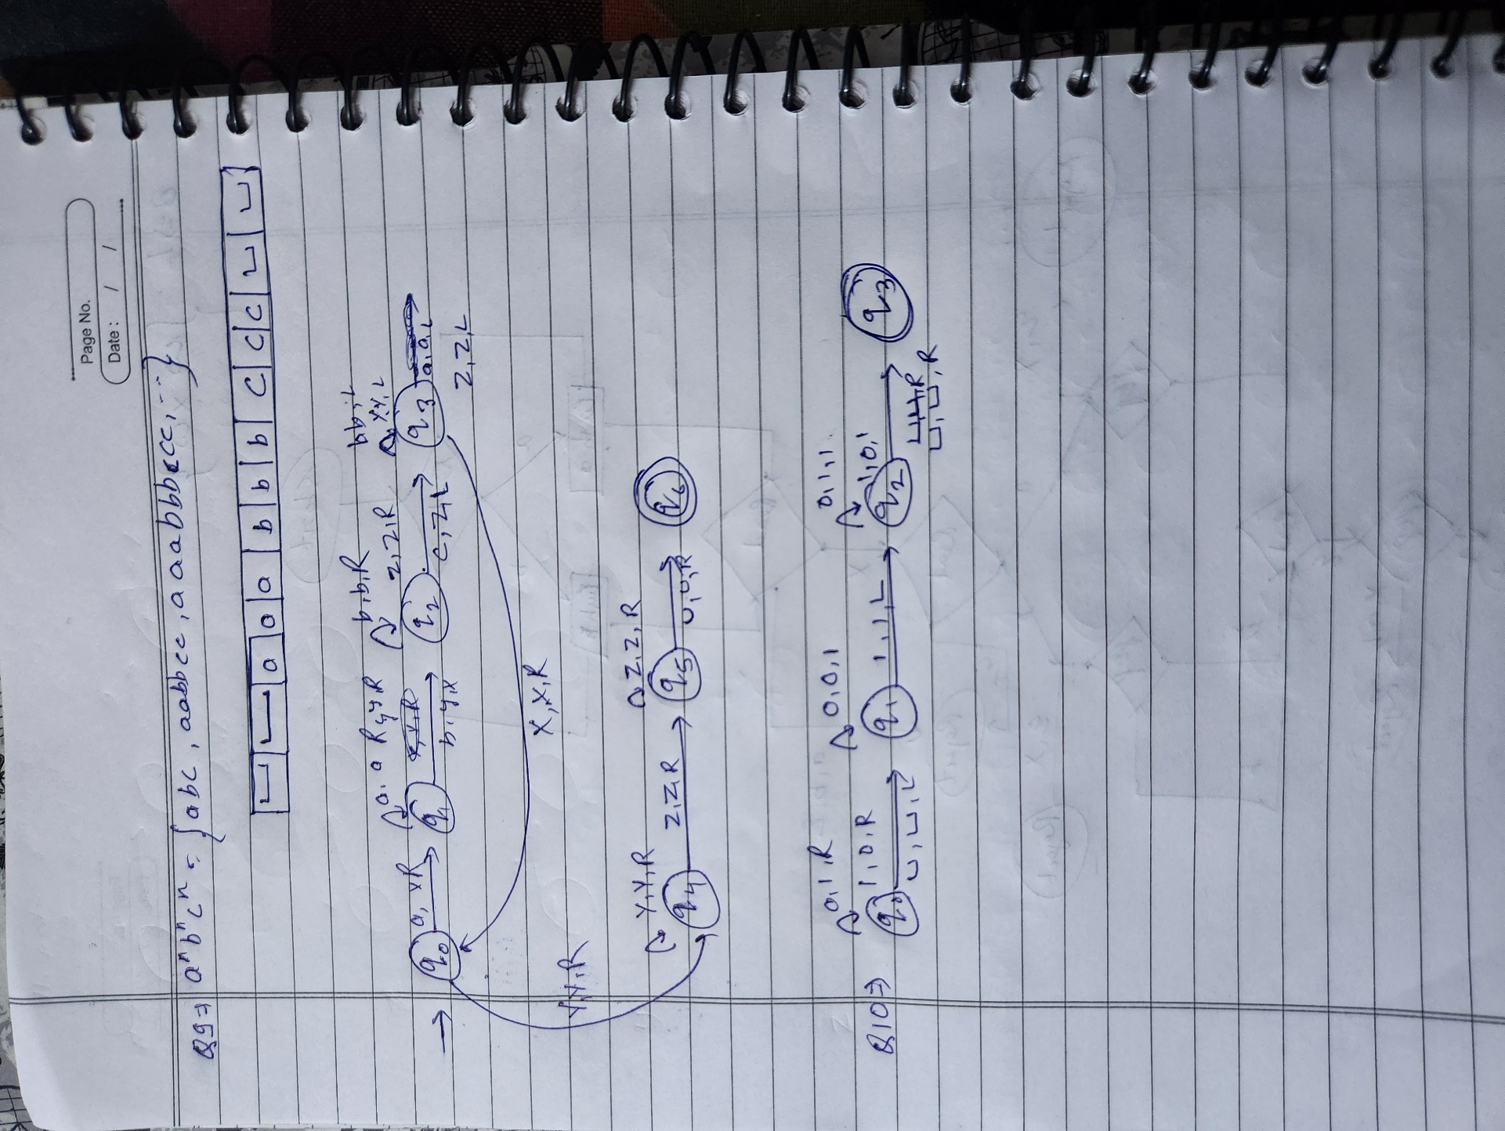

# 

# **Q10 — TM for incrementing binary number**

#include <iostream>

#include <cstring>

using namespace std;

void increment(char* in) {

int len=strlen(in);

int carry=1;

for(int i=len-1;i>=0;i--){

if(in[i]=='0'){ in[i]='1'; carry=0; break; }

else if(in[i]=='1') in[i]='0';

else return;

}

if(carry){

memmove(in+1,in,len+1);

in[0]='1';

}

}

int main() {

char w[100];

cout<<"Enter binary number: ";

cin>>w;

increment(w);

cout<<"Incremented: "<<w<<"\n";

return 0;

}

Output:

